Blue Cross Blue Shield of Rhode Island Small Group Participation Calculation Formula

Groups must enroll 75% of employees that:
- are eligible for health coverage and
- have not waived enrollment due to other health coverage.
If any eligible employees wish to waive coverage for themselves or any other dependents, the employees' waiver forms must be documented on a "Small Employer Waiver/Certification Form".
Group that does not meet participation:
ABC Company, Inc. has 15 employees eligible for benefits. 3 of the employees are covered elsewhere. 5 of the employees are declining coverage but do not have coverage elsewhere.
15 (eligible) — 3 (valid waivers) = 12
12 — 5 (declined waivers) = 7
7/12 = .58 or 58% participation
Group that does meet participation:
Use this formula to calculate participation:

___ Eligible - ___ Valid Waivers = ___
- (b) (c)

___ - ___ Declined Waivers = ___
(c) (d) (e)

___ / ___ = ___ or ___ %
(e) (c) Participation

DEF Company, Inc. has 15 employees eligible for benefits. 3 of the employees are covered elsewhere. 2 of the employees are declining coverage but do not have coverage elsewhere
15 (eligible) — 3 (valid waivers) = 12
12 — 2 (declined waivers) = 10
10/12 = .83 or 83% participation

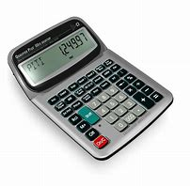

Companies may be able to increase their participation by raising their employer contribution amount or offering a lower health plan option to make the premiums more affordable for their employees.

