**HealthConnect to EaseCentral**

Once plans are finalized and the group is ready to go into Open Enrollment, HealthConnect can be used to push plans and rates, limited group information. Start a new group or go to your original quote:

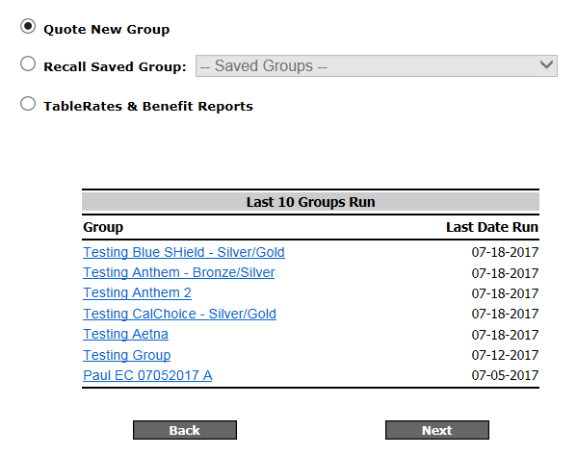

When starting a new group, enter in the **group name, zip code, SIC code, total number of eligible employs, effective date,** and **contribution**. Change the proposal status to **“Sold”** > click **Next**.

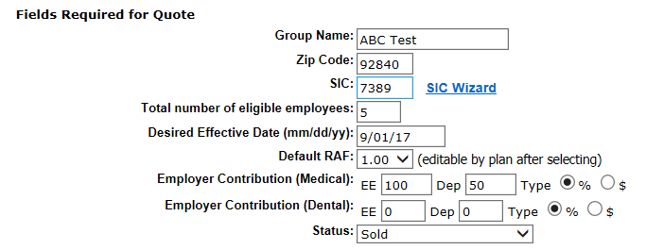

Enter in your census. Use the HealthConnect census template to import a larger number of employees. Click on **Import Census** > Choose your file > **Upload** > **Next**

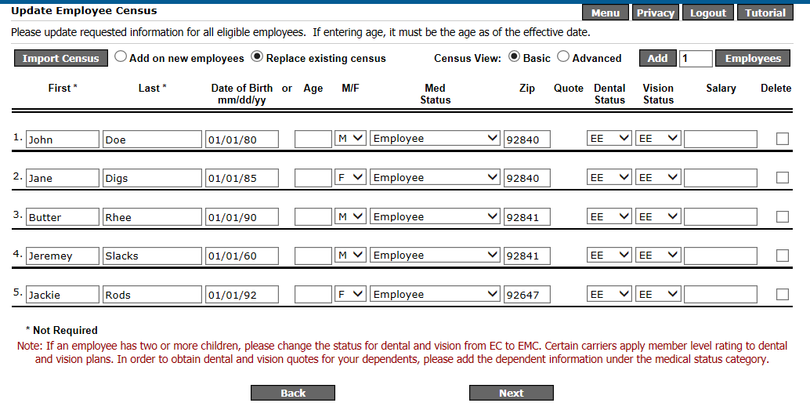

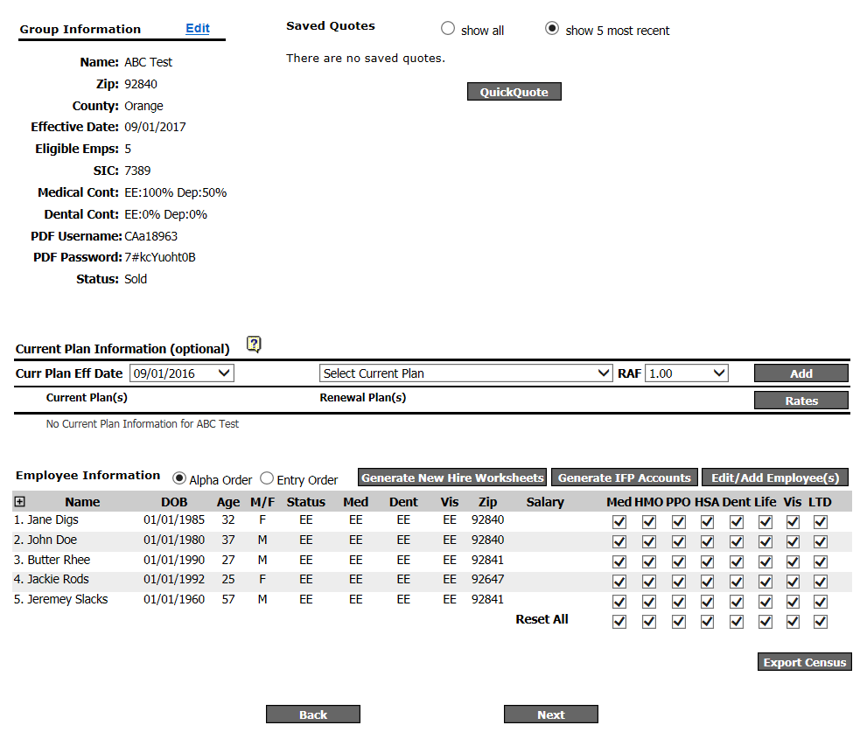

Once your group information has been entered and the census has been loaded, we are ready to “quote” our group with the final plans to be pushed over to EaseCentral. To begin click on **“Next**”.

Choose the medical carrier that has been finalized by the broker and group and then click on **“Next”** to choose the plans.

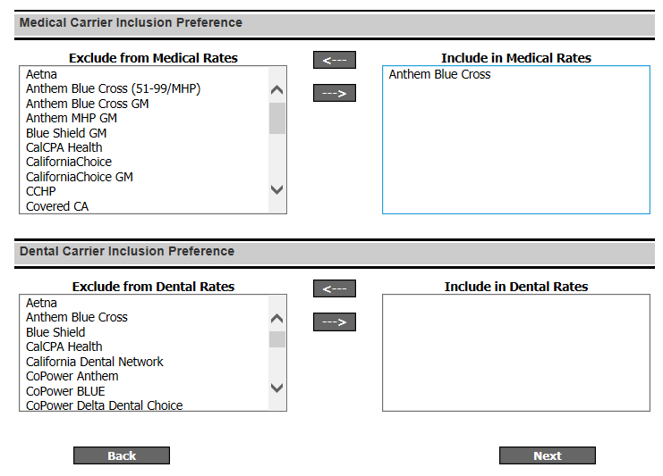

Plans will be listed for the carrier. Select the plans being offered to the group. You can filter out the plans by selecting **Type, Copay, Metal Tier, Network, Deductible, CoInsurance, and Premium**.

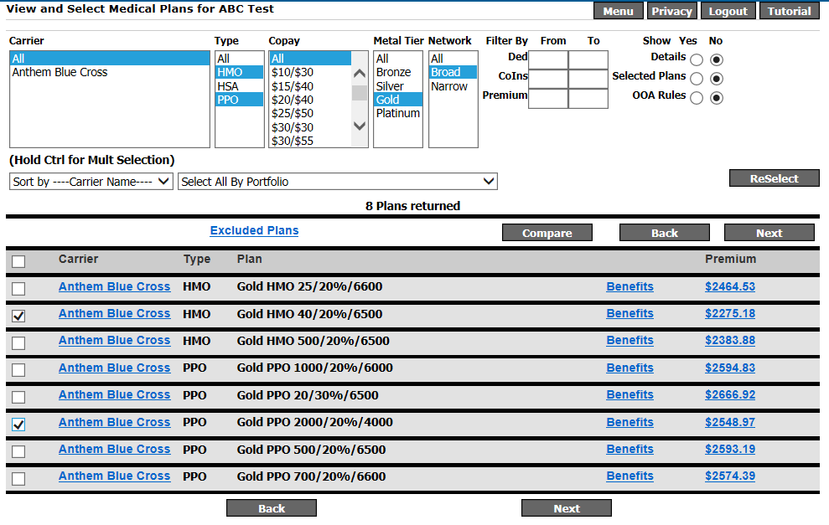

Once plans are selected, click on **“Next”.** You will review the plans selected and then proceed again by clicking on **“Next”**.

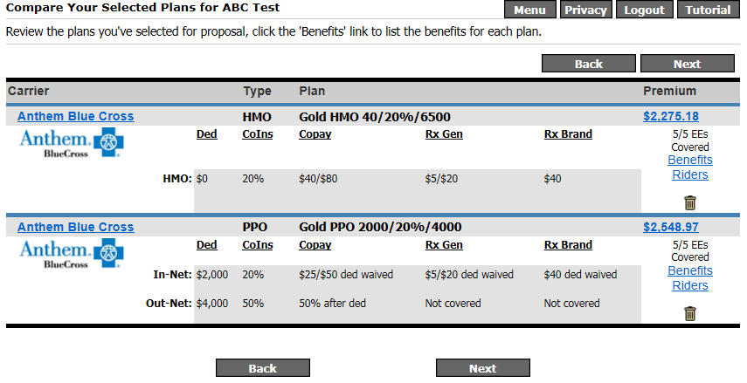

Finally, under the proposal options, you will push the finalized plans over to EaseCentral. Make sure all proposal selections are cleared and scroll all the way down to **“Enrollment Export”** and click the gray button, **“Enrollment Export”**.

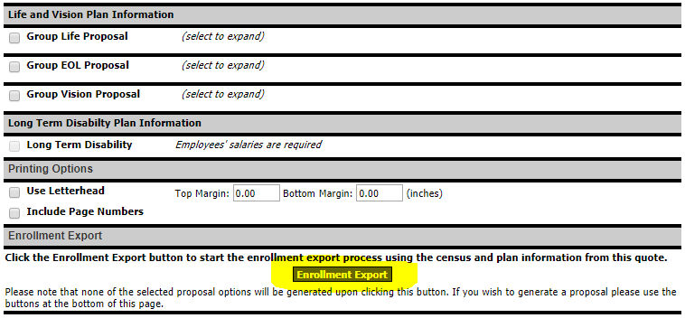

If you are going from an existing quote, you can select the finalized plans on this page or just click on **“Next”** if you created a new quote with the finalized plans. Make sure the effective date, number of employees, number of medical plans, and the plans selected are correct.

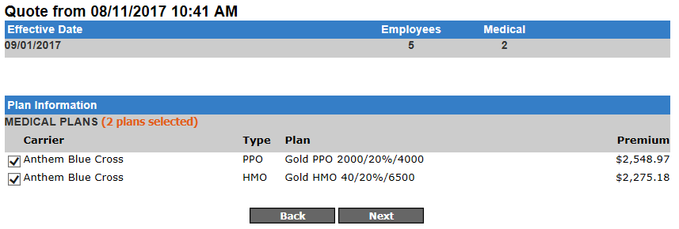

Verify the broker’s email and the contribution for this group. If the group is contributing toward a base plan, you can make the adjustments here. Also, select the correct pay cycle for the group. This will import to the group’s pay cycle to the EaseCentral platform. Click on **“Next”** to review the group information, contribution, effective date, census, and medical plans.

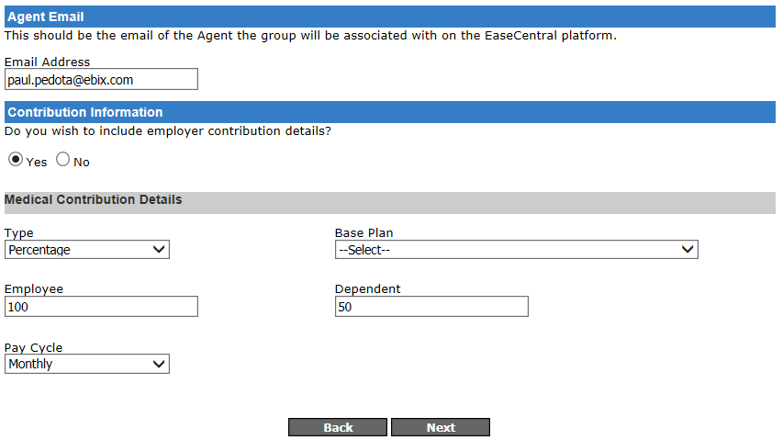

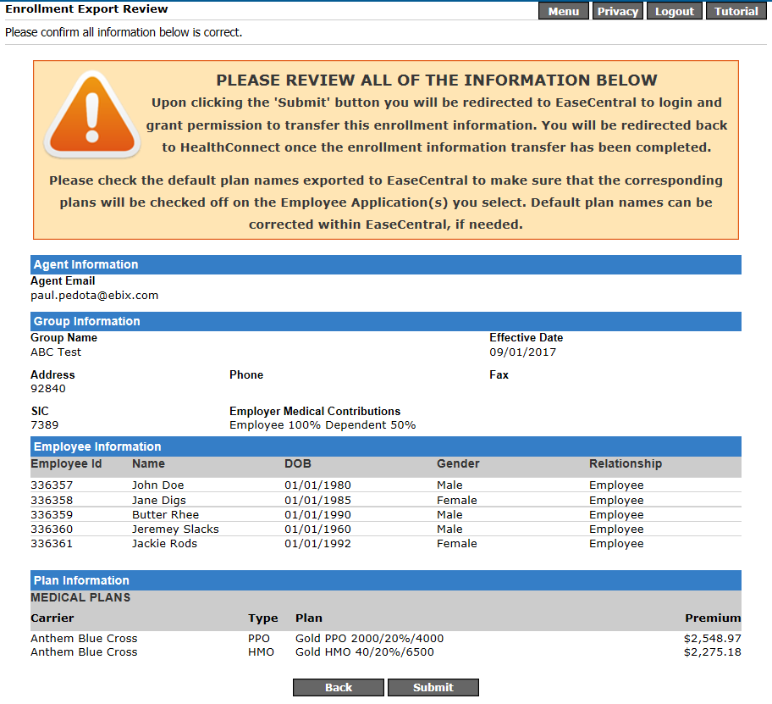

Once reviewed, click on **“Submit”**. You will be taken over to the EaseCentral sign in domain page. Enter in the broker’s subscription domain and click on **“Continue”**.

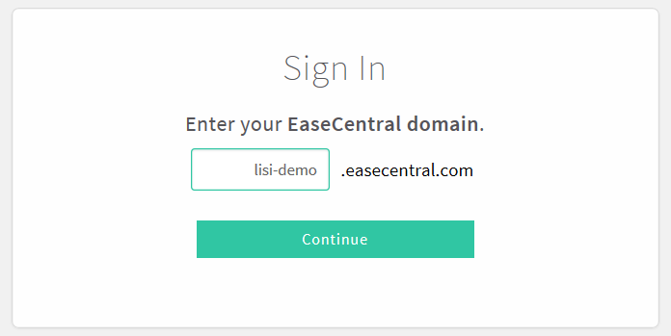

Log in with your username and password. After logging in, you will need to **“Grant Access”** to EaseConnect. This is allowing HealthConnect to push through the group’s information, census, and plans over to the brokers EaseCentral portal.

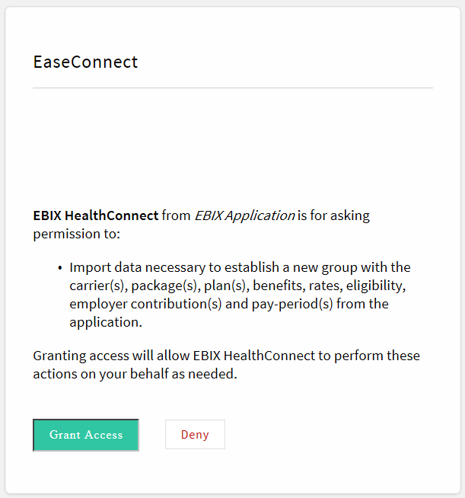

After importing the group over, the next page will confirm that it was successful. You can either return to HealthConnect’s main menu, export another group, or log out.

To complete the installation, we will need to log back in to the EaseCentral portal and make some revisions/additions to the group that was just imported.

**Profile**

Complete the group’s profile page: **Federal Tax ID (EIN), Established, Entity Type, Nature of Business, and Website**. The group name and SIC code will already be prepopulated.

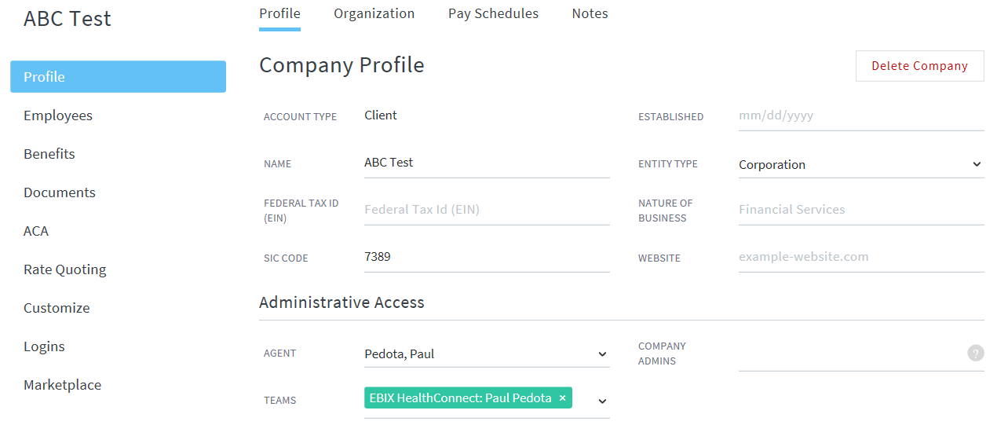

1. **Organization**Best Practice: Enter in the complete address of the group by clicking on “Edit” next to the location on the right side.If there are multiple locations, you can always add the additional ones by clicking on **“Actions”**. This is the place you would want to organize the group based on job classes, divisions, departments and job classes for benefits that have different contributions based on demographic/position.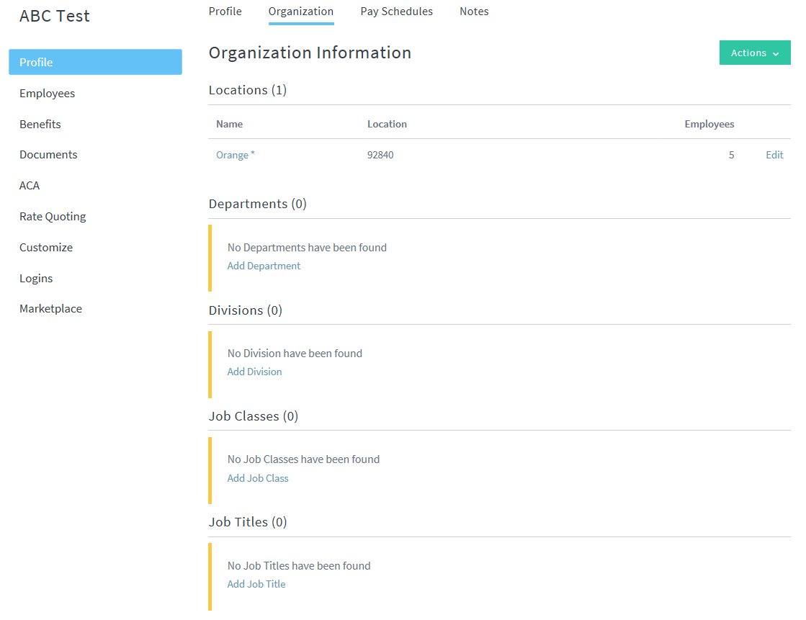

**Customize**

1. **Fields**

Customize the enrollment fields tailored to the benefits being offered for the group. Please note that the **Default Pay Cycle** will already be updated because of the integration from HealthConnect. Select the following fields as default:

Employee Fields:

* Dependents
* Disability
* Hire Date
* Job Title
* Language
* SSN

Dependent Fields:

* SSN

Enrollment/Benefit Fields:

* Previous & Current Coverage
* Medicare
* Beneficiaries (If Life is being offered)
* Waive Dependents Not Entered
* Waive Reasons
* Waive Reason Details (If carrier requires additional information for reason for waiving)
* Current Election During Open Enrollment (If current plans are within the system and broker prefers for them to be shown during open enrollment)
* Multi-Carrier Waiver Forms (If there are multiple medical carriers being offered and one requires a waiver form if an employee is choosing the other carrier)

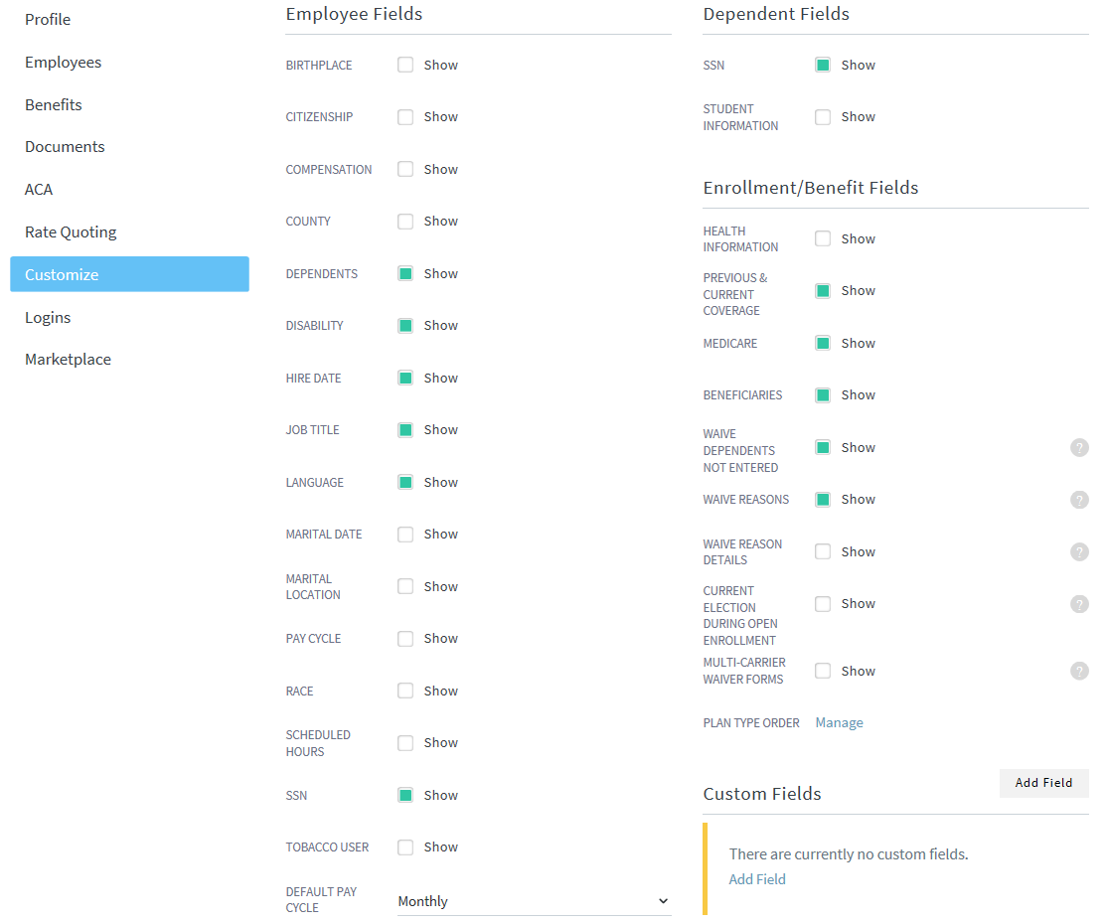

1. **Branding**The most important part of this section is entering in the company URL. This gives the company its landing page for open enrollment. The Header and Background image are optional but highly recommended to give the system a personal feel to the company.  
     
   Best Practice: The header image is to contain the company logo and the background image is usually something that has to do with the company. I try to find some pictures that is on the company’s webpage.  
     
   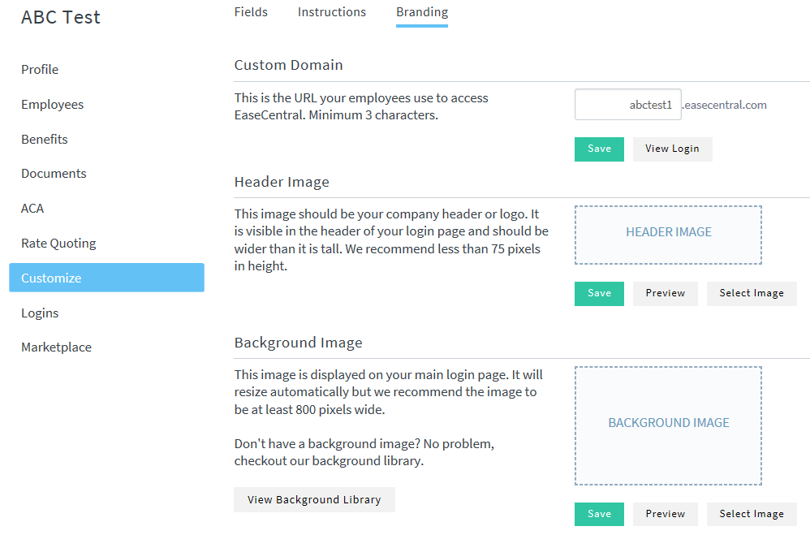

**Benefits**

Some key things to remember about the benefits section is that the benefit name will be incorrect. You will have to go into each benefit and change the display name to match the employee application and the admin name to include the plan year in the beginning of the name for best practice.

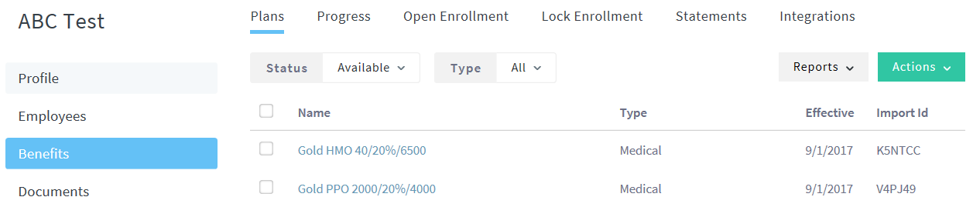

1. Profile
   * Change the admin name to “2017 Anthem Gold Prudent Buyer PPO 2000/20%/4000”.
   * Change the display name to “Anthem Gold Prudent Buyer PPO 2000/20%/4000”
   * If you are installing and HMO plan, require **PRIMARY CARE PROVIDER ID** and **PRIMARY CARE PROVIDER NAME**

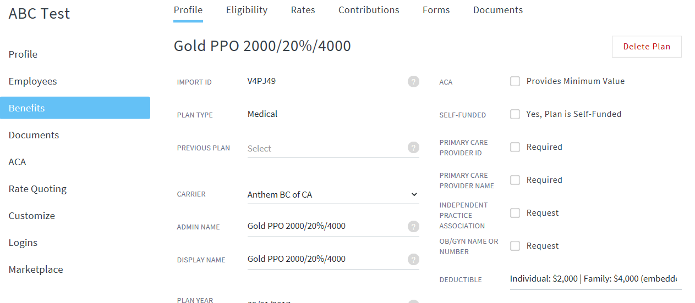

1. Eligibility
   * Enter in the waiting period
   * Change age determination based on carrier requirements (Covered CA, Health Net, Kaiser and Sutter will need to be changed to **Plan Anniversary (Ignore Hire Date)**.
   * Changes to eligibility can also include plan specifics based on job class, location, etc.

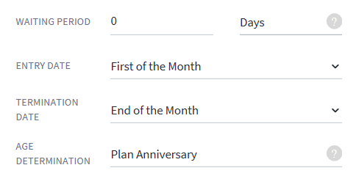

1. Rates
   * Your rates will have been imported from the HealthConnect push
2. Contributions
   * Your contribution will have been imported from the HealthConnect  
     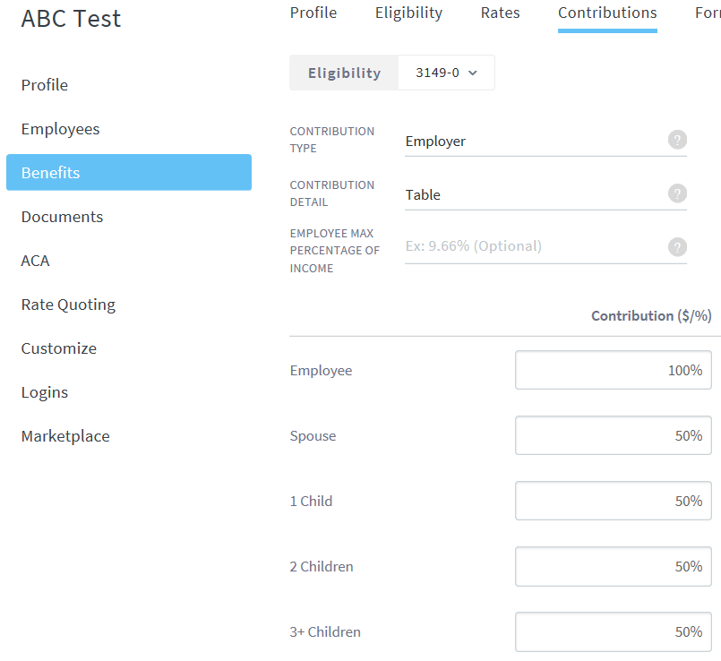
3. Forms
   * Attach the carrier form based on the effective date of the plan  
     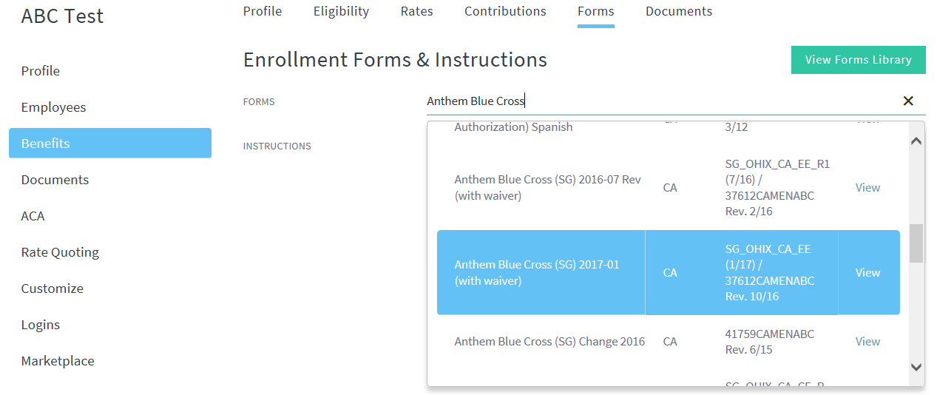
4. Documents
   * You will need to enter in all SBCs, SOBs and Provider search tool

**Employees**

The employee census will only generate what was entered to quote the group. You will have to reload any additional information that is provided (like emails). Pull an active census from the Employees section and update the census. Save it as a .csv file and reimport this file.